**TITLE: E-commerce App**

**Problem Statement**: Build an artisanal e-commerce platform using IBM Cloud Foundry. Connect skilled artisans with a global audience. Showcase handmade products, from exquisite jewelry to artistic home decor. Implement secure shopping carts, smooth payment gateways, and an intuitive checkout process. Nurture creativity and support small businesses through an artisan's dream marketplace!

**Design Thinking:**

Platform Design: Design the platform layout with sections for product categories, individual product pages, shopping cart, checkout, and payment.

Product Showcase: Create a database to store product information such as images, descriptions, prices, and categories.

User Authentication: Implement user registration and authentication features to enable artisans and customers to access the platform.

Shopping Cart and Checkout: Design and develop the shopping cart functionality and a smooth checkout process.

Payment Integration: Integrate secure payment gateways to facilitate transactions.

User Experience: Focus on providing an intuitive and visually appealing user experience for both artisans and customers.

Abstract:

The rapid growth of e-commerce has led to a significant demand for flexible and scalable e-commerce platforms. This project explores the development of an artisanal e-commerce platform utilizing IBM Cloud Foundry, a powerful cloud platform-as-a-service (PaaS) solution.

This platform aims to provide small-scale artisans and boutique businesses with a robust, cost-effective, and easily customizable solution for establishing and managing their online stores.

The project begins by introducing the concept of artisanal e-commerce and its significance in the contemporary market, focusing on the unique challenges faced by small-scale sellers.

It highlights the need for a tailored platform that allows artisans to showcase their products, manage inventory, and connect with customers seamlessly.

IBM Cloud Foundry is chosen as the underlying technology due to its scalability, flexibility, and support for multiple programming languages. The development process involves the creation of a prototype platform that incorporates essential e-commerce features, such as product listings, shopping cart functionality, secure payment processing, and user management.

**ABSTRACT:**

➢ Key aspects of the project include:

1)Platform Architecture: Detailed exploration of the architectural components, including microservices, databases, and serverless functions, that make up the IBM Cloud Foundry-based e-commerce platform.

2)User Experience: User-centric design principles are applied to create an intuitive and responsive interface for both sellers and buyers. This includes easy product uploading, product discovery, and secure checkout processes.

3)Scalability and Performance: The platform's ability to scale with demand is thoroughly tested, ensuring it can handle fluctuations in traffic and maintain high performance levels during peak periods.

4)Security: Robust security measures, including data encryption, authentication, and authorization, are implemented to protect both customer and seller data.

5)Reliability: IBM Cloud Foundry provides a number of features that help to ensure the reliability of microservices applications, such as load balancing, health monitoring, and auto-scaling.

6)Customization: Artisans can personalize their online stores by customizing the look and feel, adding branding elements, and integrating with external tools and services.

7)Cost Efficiency: An analysis of the cost-effectiveness of using IBM Cloud Foundry for small-scale e-commerce businesses compared to traditional e-commerce platforms is presented.

8)Future Directions: The abstract outlines potential future enhancements, such as AI-driven product recommendations, mobile app integration, and internationalization, to make the platform even more competitive in the evolving e-commerce landscape.

In conclusion, this project aims to demonstrate the viability and benefits of leveraging IBM Cloud Foundry to build an artisanal e-commerce platform that empowers small-scale businesses and artisans in the digital marketplace. By combining the strengths of cloud computing and a tailored user experience, this platform can serve as a valuable tool for entrepreneurs seeking to establish a meaningful online presence and connect with a global audience

**To build a project in ibm cloud foundry**

Here,application using ibm

STEP1: create an ibm cloud account

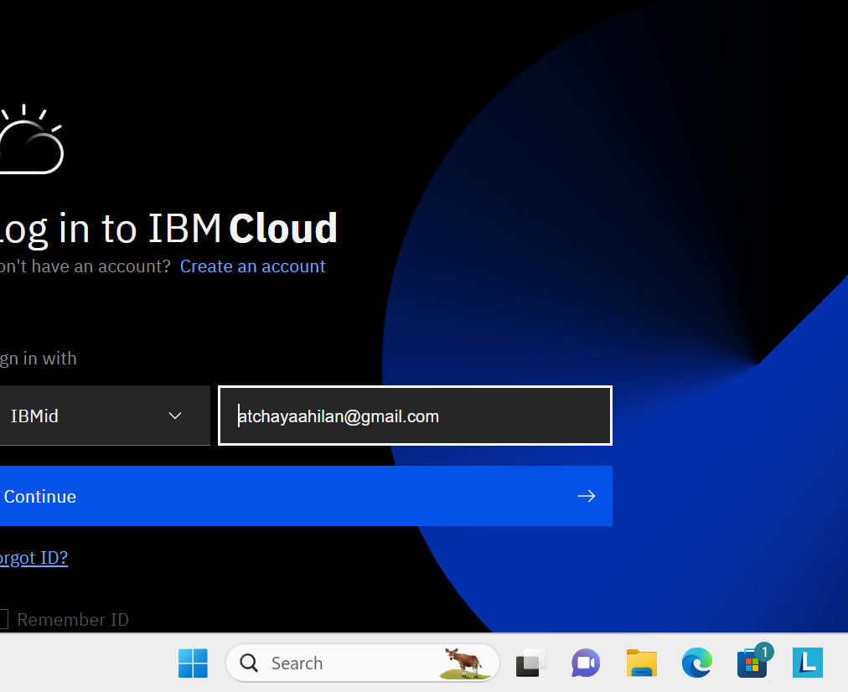

STEP2: dash board will appear like this

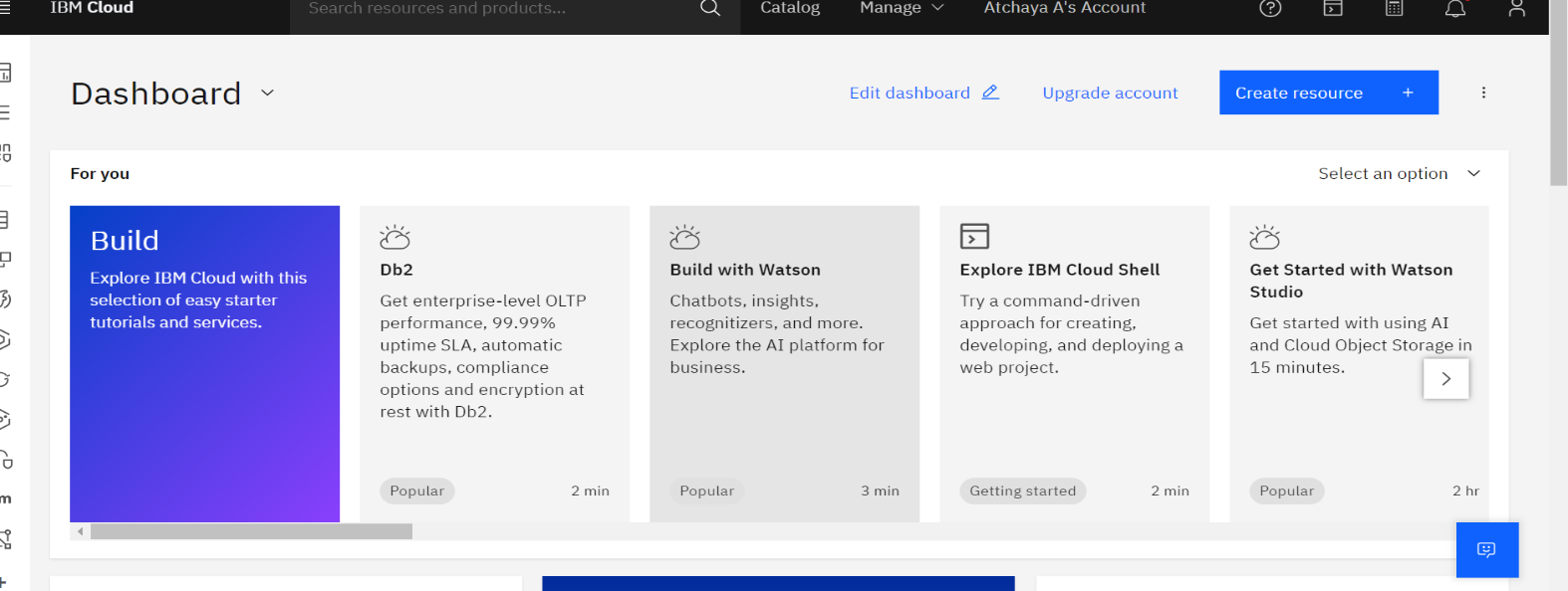

STEP3: dash board…manage our account

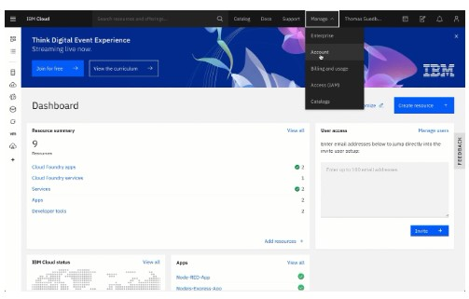

STEP 4: enter the details..

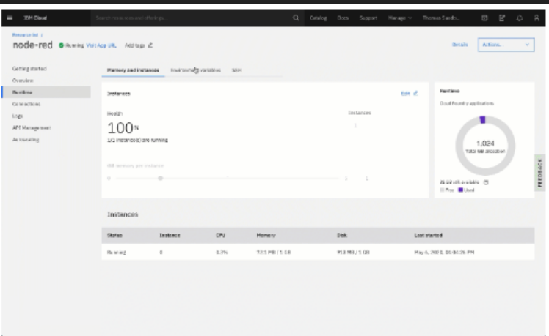

STEP5: building application

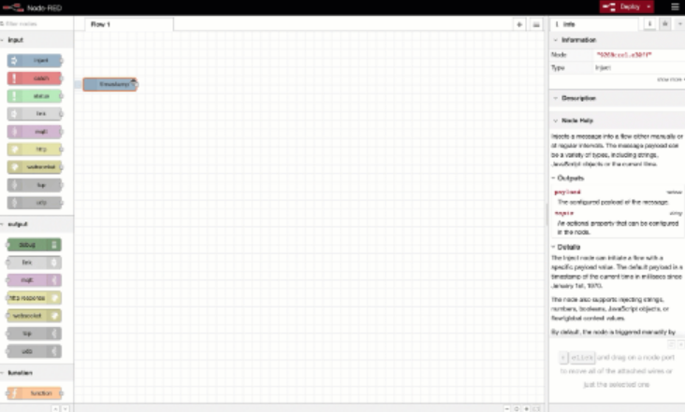

STEP6:application is formed

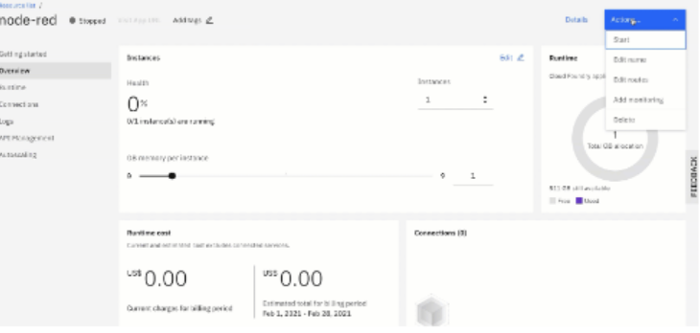

Step 7:create an e commerce platform.

In this we are creating “ORANGE STORE”



STEP 8:dash board for our app appears..

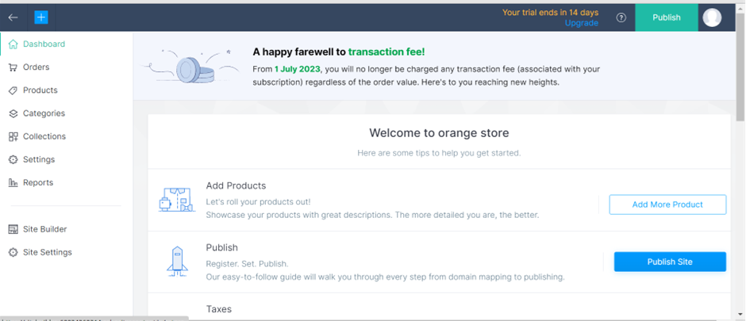

STEP9: Add product details…on selling price and retail price the details

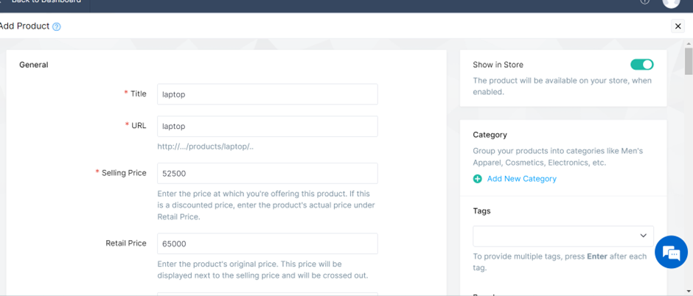

STEP10:go to products collection pg and check

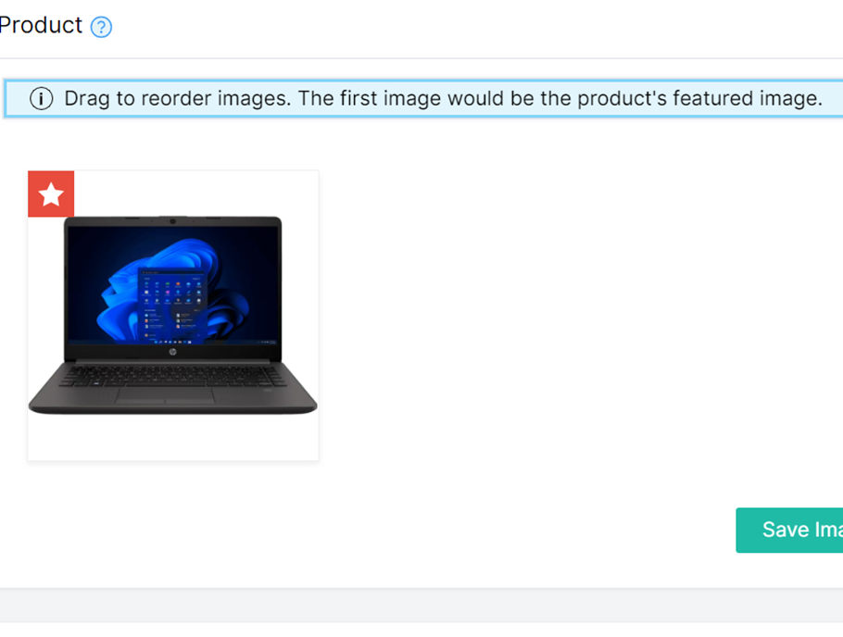

Step 11:we can publish by clicking publish…we can sell our products.

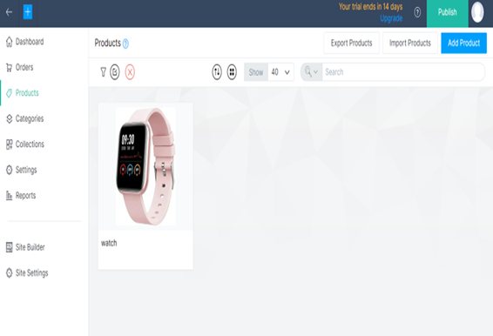

Step 12: our store is ready ..

TO DEVELOP IT USING IBM:

Step13:installing node.js

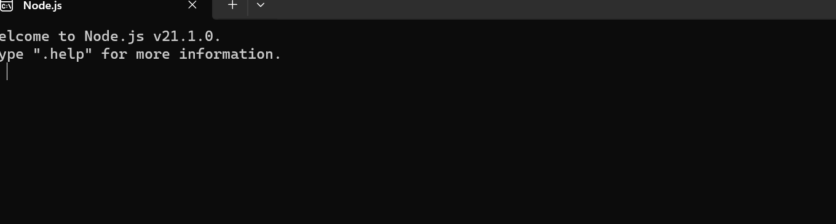

Step 14: installing docker software and open



Step 16:enter code

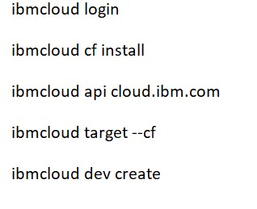

Step 17:select application type

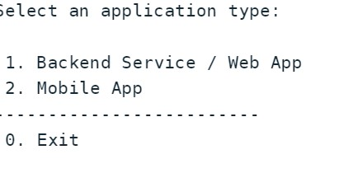

Step 18:select language

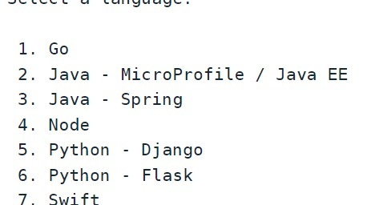

Step 19: we can build our app

CONCLUSION:

The business to consumer aspect of electronic commerce (e-commerce) is the most visible business use of the Word Wide Web. The primary goal of an e-commerce site is to sell goods and services online.